GL SpectroSoft Report

Spectrum
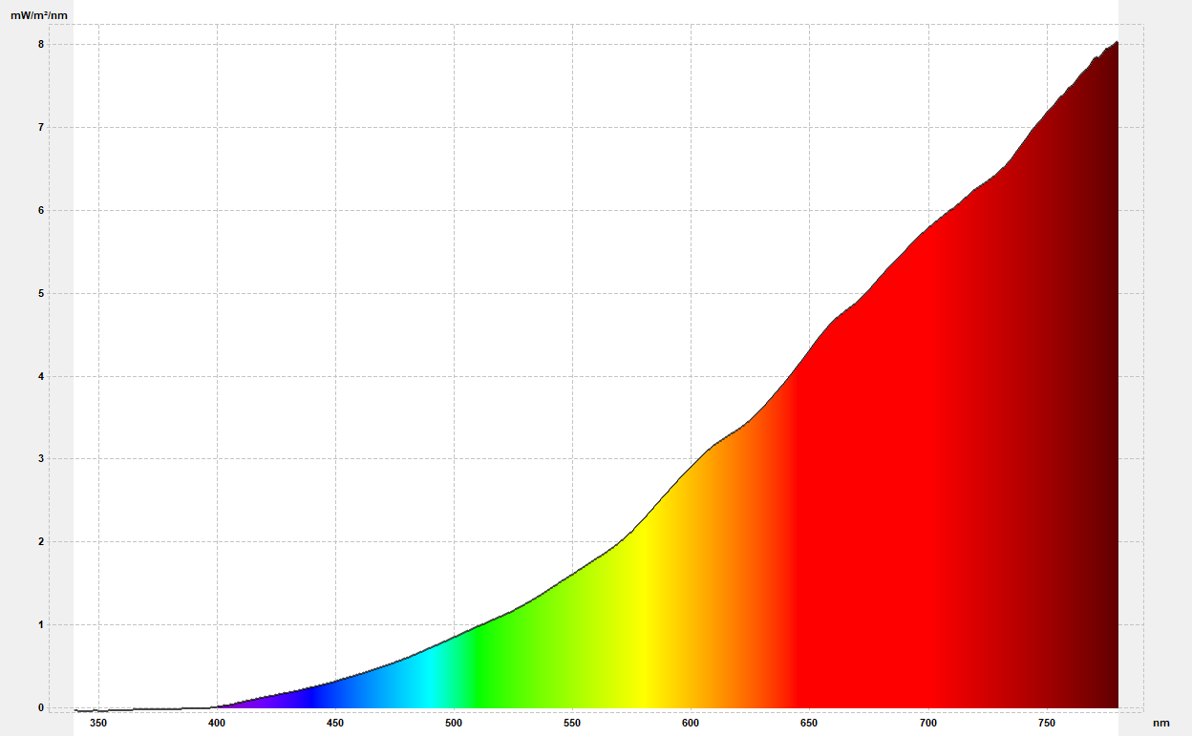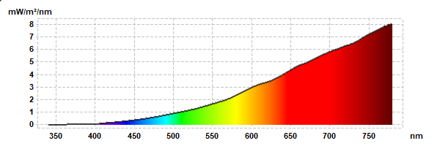
Measurement name: 2026-02-17T16:31:45  Measurement time: 2026-02-17 16:31:45  Report time: 2026-02-17 16:36:20 | Client name: LED Lamp Company  Model name: Certification according to CIE  Item No: 1122334455  Serial No.: Date 2013-09-25 13:08  Made by: <line05 name="Made by" />
Note:

Results

CIE 1931 2˚observer
x |  | 0,5046
y |  | 0,4158
u' |  | 0,2892
v' |  | 0,5361
L |  | 100,00
a |  | 42,44
b |  | 87,96
X |  | 173,16
Y |  | 142,68
Z |  | 27,31
Other
CCT |  |  | 2213
Chromaticity Error |  |  | 0,000
Color Peak |  |  | 779,40
Color Peak Value |  |  | 8,02
Color Dominant |  |  | 587,1
Luminous Intensity |  |  | 14,25
Purity |  |  | 0,763
Radiometric |  |  | 1,1831
PAR |  |  | 0,468
PPFD |  |  | 3,293
Luminous Efficacy
Rendering Indices
Ra | 98,7
R1 | 99,8
R2 | 99,2
R3 | 98,3
R4 | 99,2
R5 | 99,3
R6 | 98,0
R7 | 98,4
R8 | 97,7
R9 | 96,1
R10 | 97,9
R11 | 98,5
R12 | 96,4
R13 | 99,5
R14 | 99,1

CIE 1964 10˚observer
x | 0,5085
y | 0,4150
u' | 0,2921
v' | 0,5364
L | 100,00
a | 44,61
b | 88,82
X | 182,44
Y | 148,90
Z | 27,45

Metamerism Indices
Mivis | 4,1
Miuv | 4,0
Binning
Binning
Brightness

CIE 1931  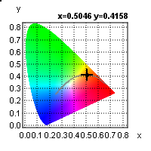 | CIE 1960  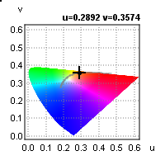 | CIE 1976  